 | 49 U.S.C. Section 5303  Metropolitan Transportation Planning Program  for a Metropolitan Planning Organization (MPO)  FFY25 FTA 5305(d) Subrecipient Application  Deadline to Apply: May 29, 2026 by 12:00pm HST
NOTE: Please complete all sections of this application. Application packages with incomplete and/or missing information will not be considered.
Agency Name: |  |  | UEI No:
Physical Address:
City: |  | County: | Island: | Zip Code:
Contact Person:
(Project Manager)
Phone: |  | Fax: | E-mail Address:
Check Area Project Application to Serve:
Urbanized Area Rural Area Small Urbanized Area
□ Oahu □ Island of Hawaii □ Kailua – Kaneohe
□ Island of Molokai □ Kahului
- Island of Lanai
- Island of Kauai
- Island of Maui
TOTAL GRANT AMOUNT REQUESTED
Federal Share (80% Grant Fund) …..…………..………….$ , . Local Share (20% Applicant Match) ………………...…….$ , .

Estimated Total Cost of Project(s)………………...……….$ , .
Authorized representative certifying the information contained in this application is true and accurate:
Printed Name: Title: Signature: Date: Email: Phone:
Applications must be transmitted to the attention of the following before the deadline:
Honolulu Department of Transportation Statewide Transportation Planning Office ATTN: 5303 Program Manager
200 Rodgers Boulevard
Honolulu, Hawaii 96819
Fax: (808) 831-7995 or Email: dotstp@hawaii.gov
Please also include an electronic copy of your complete application package on a flash drive or via email to 5303 program manager.

NOTE: While 5303 applications will be accepted until 7/1/24, it is highly recommended to apply within 90 days of fund expenditures.

1. General Information – Applicant’s Information
Name of Applicant Organization:

Address:

City: State: Zip Code: Authorizing Representative and Title:
Name:
Title:

Telephone:
Fax:
Email:

Website:

Type of Business: (choose one)
 Non-Profit Organization
 Government Entity or Metropolitan Planning Organization (MPO) Transportation Provider (Private or Public)
Previous Section 5303 Funding: (check one)


Applicant Organization has received Section 5303 funds in the past. If yes, provide the last Fiscal year the Section 5303 Project was awarded.
[
[

 Applicant Organization has never received Section 5303 funding.
Service Area: Choose one option that best describes the population size of the total service area.
 Population less than 50,000 - Non-Urbanized Area


Population between 50,000 - 199,999 - Urbanized Area Population equal to or greater than 200,000 - Urbanize Area

2a. Applicant Organizational Structure
Describe the overall structure of your organization. If available, provide an Organization Chart.

Number of Employees: (The number and type of your employees.)

Full-Time
Part-Time
Volunteer
Contract
Other (describe):
Other (describe):

Service Years: (Identify the number of years your organization has been in business and service years.)
year(s) Applicant Organization has been in business
year(s) transportation services were provided
year(s) transportation services were provided for the elderly and/or disabled

2b. Applicant Organization's Transportation Management Information
Describe the organization’s experience in providing services for your agency’s expertise:

Agency Human Resources (Describe the employee position(s) your agency utilizes for operations and management, roles and responsibilities, and number of hours performed by each per week.)

3a. Funding Summary

- Identify Type of FTA Funds to be used:

- Identify Federal Fiscal Year (FFY) of funding to be used:

- Identify Source of Local Funds and provide documentation:

- Provide an explanation of project(s) and benefit(s):

- Provide Period of Performance “POP” (The dates activities occur for each work element):

- Does this Application include funds for “Research and Development Activities?”:

- Will “Indirect Costs” be applied to this Application? If Yes, provide proof of Federal Approval:

3b. Matching Share Assurance Summary

The agency commits to provide the local matching share for these grants in accordance with the following schedule:

Agency Name | FTA Federal Share (80%) | Local Match (20%) | Cash or In-Kind Services ($) | Total Amount (All funding sources)

Identify the source of your local match, cash or in-kind services and provide documentation:

3c. Fiscal Year Detailed Breakdown of Funds

To the best of your knowledge, provide the fiscal year breakdown of funds to be utilized:

FTA 5303 Funds | FFY2023 | FFY2024 | FFY2025 | FFY2026
Current Balance
Used this Grant
Remaining Balance

3d. Work Program and Work Elements

- Provide the name/title of your agency’s work program:

- Describe the approval and/or amendment process for your agency’s work program:

- How often is your work program prepared (i.e. number of years):
- Provide a copy of your most recently approved work program. (attach a file)

- Provide the approval date of your latest work program (month/day/year):

Provide the work program elements or line items utilized in this grant (i.e. overhead costs, program administration, etc.):

Scope Code | Activity Line Item Number | Work Element Number | Work Element Description
442-00 | 44.21.00 | 301.01 | Program Administration
442-00 | 44.21.00 | 302.01 | Overhead Costs
Other_________
Other_________

3e. Sources of Funding Matrix for Work Program Elements
Provide matrix which includes the work elements by line item identified in 3d., to demonstrate the distribution of funding sources utilized for this grant.

Work Element (Details) |  |  | Local Match (Funding Sources) |  |  |  | FTA Grant Application
Activity Line Item (ALI) | Scope Code (000-00) | Work Element (Number) | Fund Source (1)  Specify: | Fund Source (2)  Specify: | Fund Source (3)  Specify: | In-Kind Services or Cash ($) | Total Agency Match (20%) | Total FTA 5303  Funds (80%) | Total Grant Amount (100%)

3f. Extended Budget Description
Identify tasks associated with your first work element line item (i.e. program administration):

Written explanation of costs incurred or intended to be incurred for first work element (i.e. paragraph):

Select checkbox for all that apply:
- General Technical Assistance and Planning Support
- Computer and Network Maintenance
- OWP Development and Management
- Subrecipient Monitoring and Support
- Accounting
- Training, Education, Workforce Development

Identify tasks associated with your second work element line item (i.e. overhead costs):
Written explanation of costs incurred or intended to be incurred for second work element (i.e. paragraph):

Select checkbox for all that apply:
- Office Space – includes the costs of the monthly rent, the common area maintenance fee, and the GET tax.
- Photocopier – includes the cost of the monthly base rent of the photocopier and the per page printing costs.
- Telephone – includes all costs, fees, and taxes from local utility provider.
- Postage – includes the costs of purchasing postage from the U.S. Postal Service, refilling the postage meter, and any other shipping costs, such as sending packages by Federal Express or United Parcel Service
- Printing – includes any costs associated with having any official agency document, letterhead stationery, or public outreach material professionally printed
- Miscellaneous/Contingency – is an earmark of last resort for any unforeseen need that is not covered by another category, or for any additional funding (as needed) for a work element.
- Office Supplies – includes the costs of typical office supplies and necessities, such as pens, paper, calculators, data CDs, envelopes, paperclips, etc.
- Equipment – includes the costs of purchasing or leasing any necessary office equipment.
- Computer & Peripheral Equipment – includes the cost of purchasing any computers, computer hardware, components, and peripheral equipment, as deemed necessary.
- Website Hosting – includes the cost of hosting and maintaining your agency website

Identify tasks associated with your third work element line item (i.e. other, not listed above):
Written explanation of costs incurred or intended to be incurred for third work element (i.e. paragraph):

List of activities to be performed (not listed elsewhere):
1)

2)

3)
4)

5)

6)

4. Project Milestones – For each ALI, list the beginning and end dates for all activities to be performed.
Fill-in the table below in order to demonstrate the timeline or timeframe for all activities occurring within each activity line item (ALI):

Work Element (1):

Activity to be Performed | Start Date | End Date

Work Element (2):

Activity to be Performed | Start Date | End Date

Work Element (3):

Activity to be Performed | Start Date | End Date
Note: Add additional line items to show all activities within a separate file, as needed.

5. Executive Summary – Project Purpose and Public Benefit (describe for each activity line item).

Purpose: Describe the overall reason for the project. Indicate how it is essential to services provided by your organization.

Activities to be performed: Describe the activities to be performed for each line item.

Expected Outcomes: Describe the expected outcomes for the activities to be performed.

Intended Beneficiaries: Describe the benefits to be gained by the program, applicant organization, public, community, government, economy, etc.

Describe the deficiencies and shortcomings to the organization’s existing and future services, or other negative outcomes that may arise should the project not be awarded.

6. Financial Information

Financial Statement - Provide and attach for the current or most recent period and two previous years. These statements will be used to review financial stability and sustainability.

Fluctuations in Revenue and Income - If fluctuations in estimated revenue or expenses vary or are expected to vary over the next two years, provide the reasons for the anticipated or actual fluctuations and how such fluctuations will affect the organizations's financial stability and sustainability.

7. Legal Information
Legal Resource (check one)
 The Applicant Organization has legal counsel
[
The Applicant Organization does not have legal counsel
[
8. Project Environmental Findings

For each activity line item provide the following: (see applicable exemption list) Class Level Description:

Categorical Exclusion Description:

9. Third Party Contractor Disclosure

For each activity line item, indicate whether or not a third-party contractor will be used:

1)

2)

3)

10. Certifying Authority
I am duly authorized to make the following certification on behalf of the Applicant Organization and based on my position, knowledge and experience with the Applicant Organization:
- the information contained in the Application, including attachments, is true and correct;
- the Applicant has the requisite fiscal, managerial, and legal capabilities to carry out the operations and maintenance of the Project in accordance with 40 U.S.C. Section 5303; and
- the Applicant shall adhere to the federal, state and local requirements related to the Project.

,
Signature Title

Executed on at Date City/County and State

Activity Line Item (ALI) Codes
(for reference only)

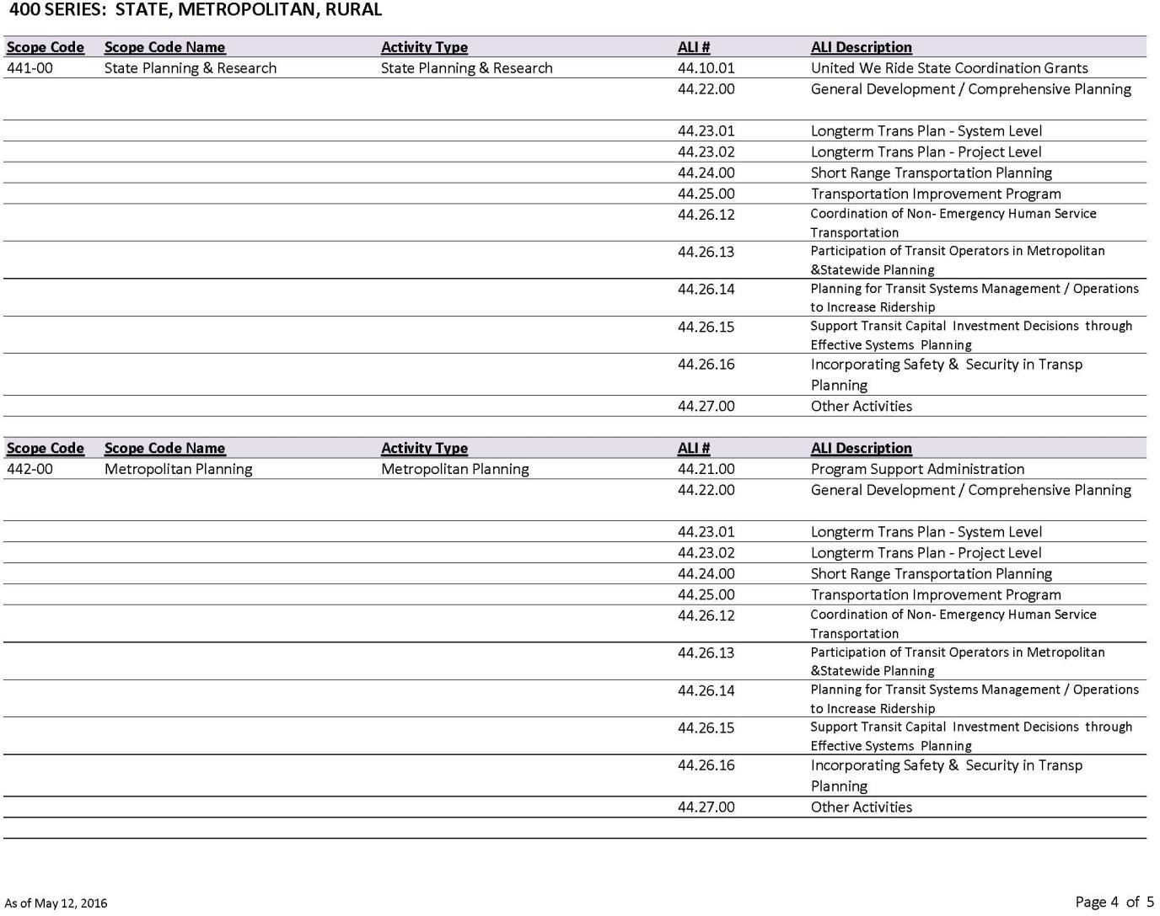

Pre-Award Authority Request

STATE OF HAWAII DEPARTMENT OFTRANSPORTATION
STATEWIDE TRANSPORTATION PLANNING OFFICE
200 RODGERS BOULEVARD
HONOLULU, HAWAII 96819-1812
Pre-Award Authority Request

Pursuant to Federal Register Notice Vol. 86, No. 175 dated September 14, 2021:
FTA will issue specific guidance to recipients regarding pre-award authority at the time of selection. FTA does not provide pre-award authority for competitive funds until projects are selected and even then, there are Federal requirements that must be met before costs are incurred. Funds under this Notice of Funding Opportunity (NOFO) cannot be used to reimburse applicants for otherwise eligible expenses incurred prior to FTA award of a Grant Agreement until FTA has issued pre-award authority for selected projects, or unless FTA has issued a ‘‘Letter of No Prejudice’’ for the project before the expenses are incurred. For more information about FTA’s policy on pre-award authority.

Notice to all grant applicants:
Consistent with FTA policy on pre-award authority, a project must have met all applicable Federal requirements prior to incurring expenses. The recipient assumes all risk and is responsible for ensuring that all applicable federal program and grant requirements are met to retain eligibility. Recipients are also advised that incurring certain project costs prior to NEPA completion may render the entire project ineligible for Federal assistance. Therefore, FTA strongly encourages all recipients to consult with the appropriate FTA regional office regarding the anticipated environmental review requirements and the applicability of Federal conditions and requirements before incurring expenses under pre-award authority with the hope of future reimbursement.

To that effect, attach supporting written documentation which addresses all of the following requirements:
- The pre-award time period.

- The line-item budget for the time period.

- The costs incurred to date (or anticipated to be incurred) prior to award.
- A narrative description of the tasks already completed (or anticipated to be completed).
- A compelling justification explaining why it was (or is) necessary to start earlier than the anticipated award date.

Applicant Name: Authorized Signature: Date: Printed Name and Title:

Pre-Award Authority Administrative Process
STATE OF HAWAII DEPARTMENT OFTRANSPORTATION
STATEWIDE TRANSPORTATION PLANNING OFFICE
200 RODGERS BOULEVARD
HONOLULU, HAWAII 96819-1812
Pre-Award Authority Administrative Process

Pre-award costs may only be considered where costs are incurred prior to the award, but after program authority has been enacted and the appropriation becomes available. If pre-award costs are incurred before the funding becomes available, but after program authority exists, pre-award costs may be awarded on a case-by-case basis, depending on statutory language, legislative history, or other particular factors, such as applicable program regulations.
Pre-award costs incurred before both program authority and funding are available may generally not be funded retroactively. Questions about availability of appropriations for pre-award costs should be directed to the Program Manager for your Federal Transit Administration (FTA) grant recipient authorized through the State of Hawaii Statewide Transportation Planning Office (STPO) with the Hawaii Department of Transportation (HDOT).
Approval of pre-award costs should be kept to a minimum. Generally, the period for such costs should not exceed ninety (90) days prior to the start of the project period.
When a request for approval of pre-award costs is required, an applicant should provide a written request to the HDOT STPO Program Manager at the earliest possible time.

The request should contain the following information:
- Pre-award time period,
- Line-item budget for the time period,
- Costs incurred to date or anticipated to be incurred prior to award,
- Narrative description of the tasks already completed or anticipated to be completed, and;
- A compelling justification explaining why it was necessary to start earlier than the anticipated award date.

The Program Manager will review the request and provide a recommendation to FTA for approval. FTA will review the recommendation and the applicant's request. If the pre-award request is disapproved, FTA will notify the recipient (HDOT) in writing. If the request is approved, notice will be incorporated into the grant award document.

Note: See 15 CFR § 14.25(e) for prior written approval requirements for pre-award costs, including the requirements for research awards.

