How to load the QK Google earth Map into Google Earth

- Make sure you are using Chrome as your browser. You don’t have to make it you default, but you need it for Google Earth.
- Type in the search bar “google Earth”
- Google Earth will load. Press button that says “launch earth”
- Choose “Projects” icon (1) to get to the screen below.
- Click on the “new project button (2).
- Click on” Import KML file from computer” (3) (file should be attached to same e-mail this document was in).
- File will load and the map will pop up. (4)
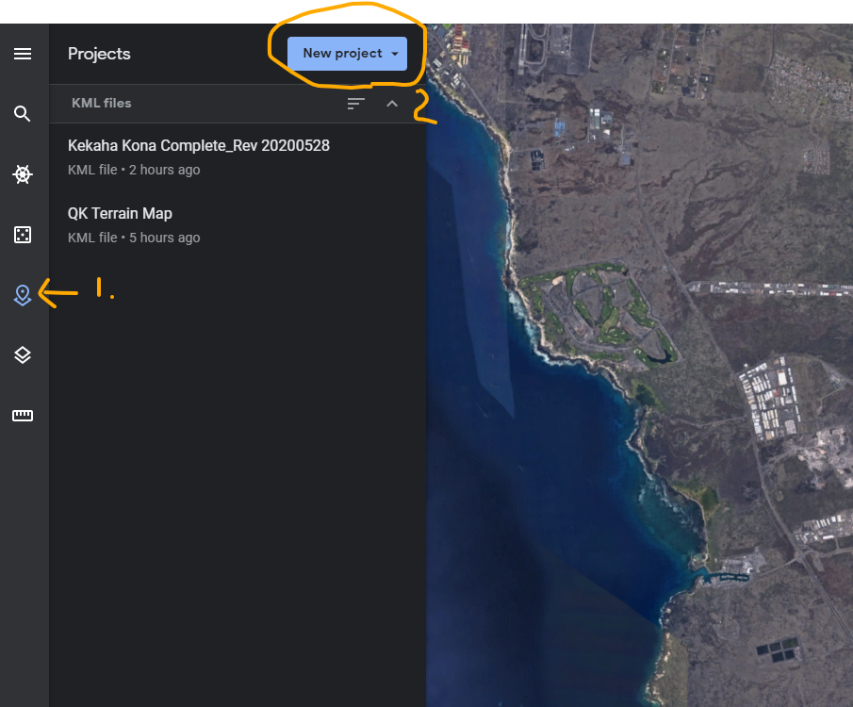
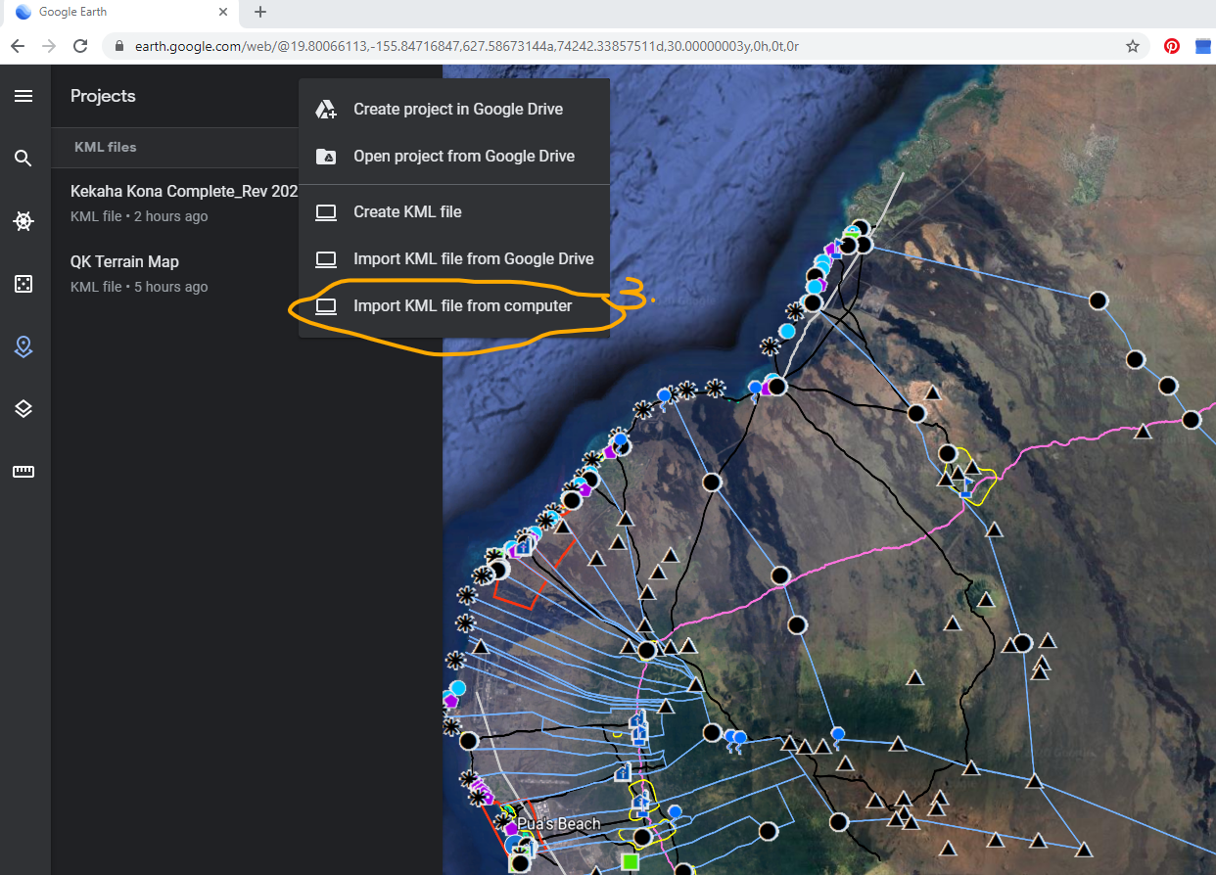

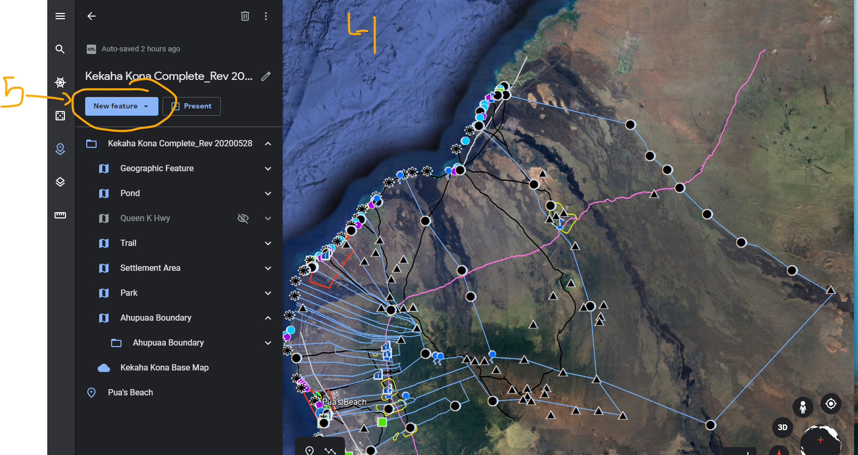

To add features:
Locate where you want your feature to be.
Press “New Feature” Button (5)
Choose from the options available (6). Using a pin or a line allows for a link to the map so choose a pin or a line. I’ll use a pin for the example.
Move the pin or line icon where you want it to go and drop it in place. (7)
Click on your pin or line and this box will open up (8).
Add your picture, link or text to the correct boxes (9) and click the back arrow (10)

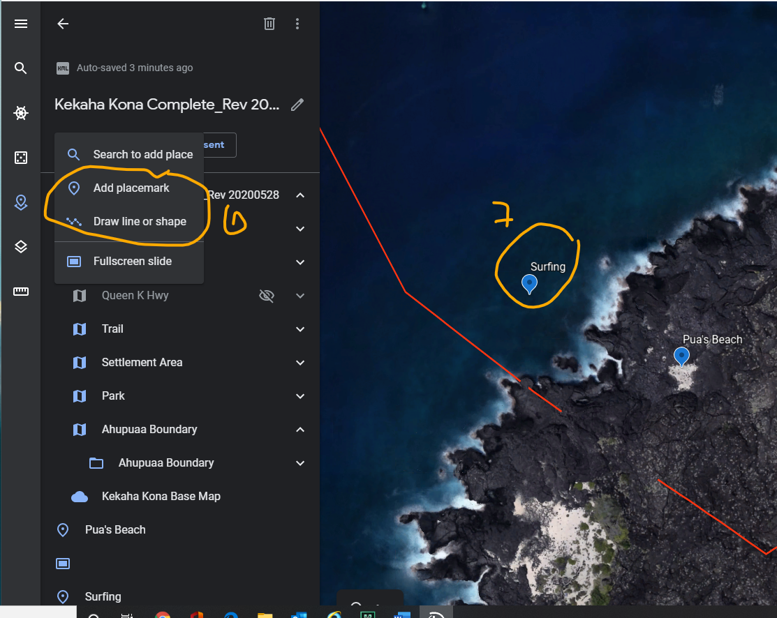

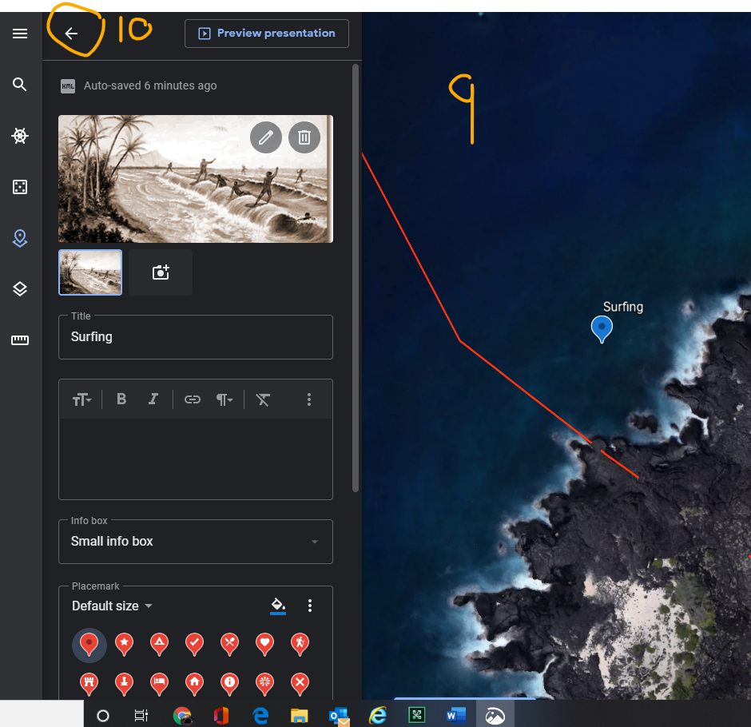
Now when you click on your surfing pin, you get a picture (or link, or text) associated with it.

