Queen Ka‘ahumanu Highway Widening Project Agenda
106 Consultation Meeting
April 4, 2020
9:00am to Noon

Everyone should join by phone: Join by phone: 1-888-808-6929 Passcode 3528678
(During prior meetings we learned that we could hear each other more clearly by connecting by phone. Also it’s best if you mute your phone when not speaking, this also adds clarity to the transmission.)

You may also join by computer which will give you more options to interact with the group. If you want to use the computer access, please click on this link prior to the meeting (allow enough time for the program to load before the meeting): https://connectdot.connectsolutions.com/wen2018/
The computer screen upper left-hand corner will look like below: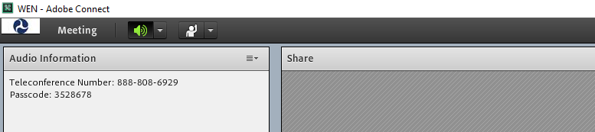
#1 Mute Button
#2 Interaction Options
- When you connect by phone and computer, please mute your computer to avoid feedback. The mute button is in the top left screen, as shown in green in the picture above. Press the down arrow next to it and click on “Mute my Speaker” and then speaker Icon will turn white.
- If you would like to speak, raise your hand using the interaction options accessible by the down arrow next to the raised hand - #2

#3 – write comments or questions in this area

- If you would like to submit a written comment or question, utilize the chat pod shown above – it is located in the lower left corner of the screen.
AGENDA

- Pule (by one of the Consulting Parties)

- Introductions will be led by Faith based on who has connected with the meeting by computer or phone.
  - Faith/Lisa facilitating,
  - Anna notetaking

- Protocol for the meeting
  - Just like the previous meeting with a few new protocols.
    - Kapu Aloha and treat each person with respect.
    - Please utilize raise hand icon if you would like to speak and you will be called on. For those only on the phone – Faith will ask periodically if anyone has comments or questions.

- Update on After Action Analysis (HDOT)

- Discussion of proposed mitigation of breached sites presented at Feb. 8th meeting in Draft Amendment 2

- Next Steps

- Pule

