Queen Ka‘ahumanu Highway Widening Project Agenda
Meeting on ACHPs advice to Makani Hou objection and FHWA Response
September 24, 2020
1:00 pm to 3:15 pm

Everyone should join by phone: Join by phone: 1-888-808-6929 Passcode 3528678
(During prior meetings we learned that we could hear each other more clearly by connecting by phone. Also, it’s best if you mute your phone when not speaking, this also adds clarity to the transmission.)

You may also join by computer which will give you more options to interact with the group. If you want to use the computer access, please click on this link prior to the meeting (allow enough time to connect through Adobe Flash Player or Adobe Connect): https://connectdot.connectsolutions.com/wen2018/
The computer screen upper left-hand corner will look like below: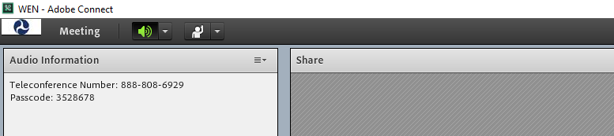
#1 Mute Button
#2 Interaction Options
- When you connect by phone and computer, please mute your computer to avoid feedback. The mute button is in the top left screen, as shown in green in the picture above. Press the down arrow next to it and click on “Mute my Speaker” and then speaker Icon will turn white.
- If you would like to speak, raise your hand using the interaction options accessible by the down arrow next to the raised hand - #2

#3 – write comments or questions in this area

- If you would like to submit a written comment or question, utilize the chat pod shown above – it is located in the lower left corner of the screen.
- (Optional) To share a webcam of yourself, click the icon:

AGENDA

Time | Topics | Lead
1:00pm | Pule | One of the Consulting Parties
1:05 | Introductions | FHWA facilitating  Anna notes
1:10 | Review protocols for the meeting:  - Kapu Aloha, treat each person with respect  - To speak  - Computer users: Use hand icon if you would like to speak. Chat box also available.  - Telephone only – Lisa will ask periodically if anyone has comments. | Lisa
 | Discussion of ACHP Advice and FHWA Comments:
1:15 | General Objections
1:25  1:35  1:45  1:55  2:05  2:15  2:25  2:35  2:45  2:55  3:05 | Stipulation 3 – Professional Standards  Stipulation 4 – Archeological Preservation and Mitigation Plan  Stipulation 5A – Project Redesign  Stipulation 5B – Native Hawaiian Cultural Outreach and Education  Stipulation 6 – Cultural Monitors  Stipulation 8 – Noise Study  Stipulation 10B – Underpass Feasibility Study  Stipulation 12 – Ahupua’a Signs  Stipulation 14 – Relationship Building Workshop  Stipulation 15 – Terrain Model  Stipulation 17 – Post-Review Discoveries
3:15 | Pule | One of the Consulting Parties

