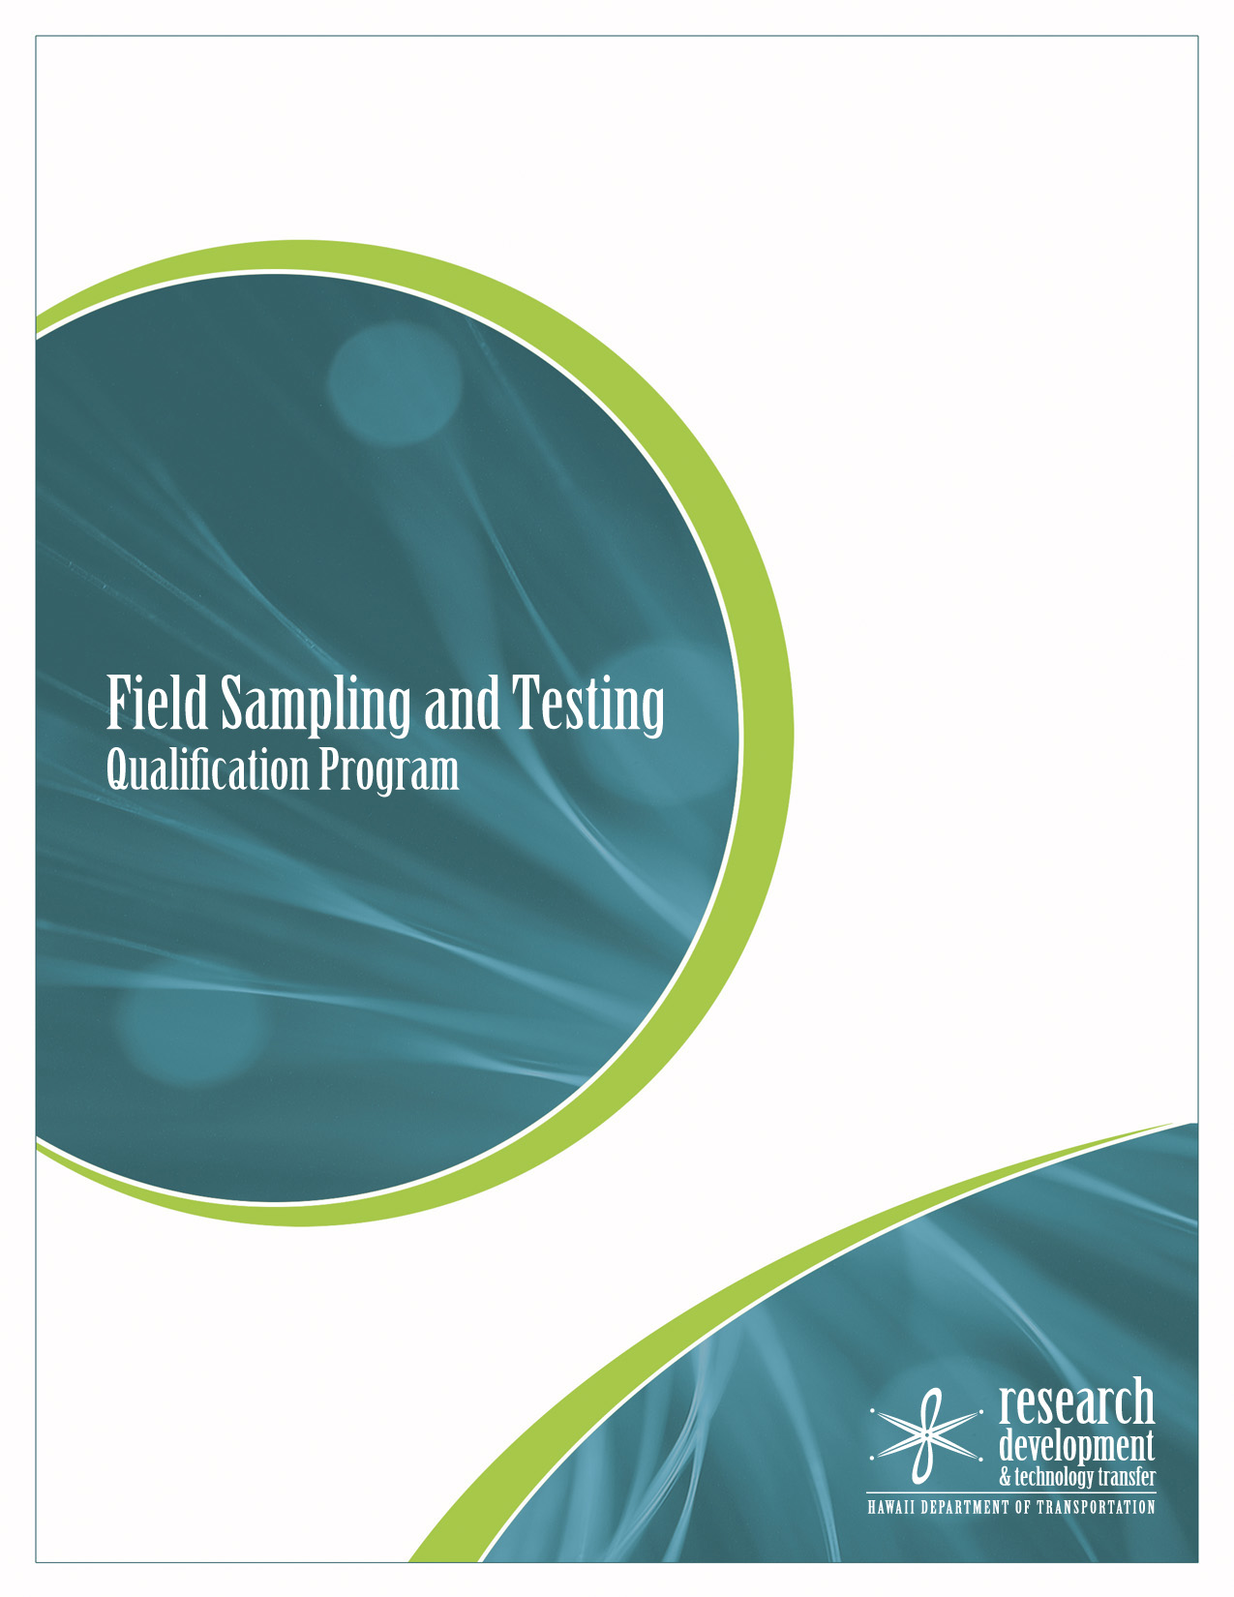

February 2020-April 2020

1

1
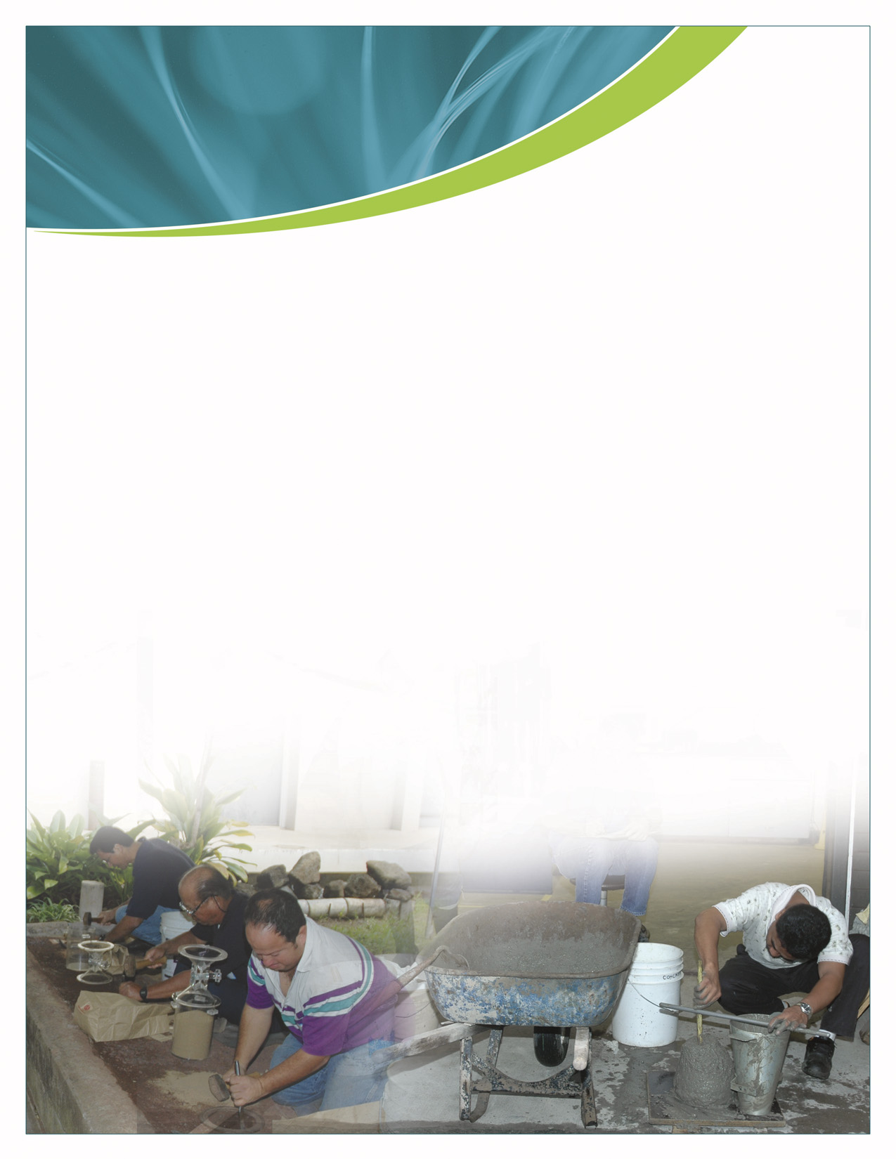

The Personnel Qualification Program for Field Sampling & Testing has been developed for the purpose of qualifying persons in the sampling and testing methods for which they have demonstrated the knowledge and ability to properly perform the procedures required by those methods. The Materials Testing and Research Branch (MTRB) has partnered with The Hawaii Asphalt Paving Industry (HAPI) and the local Concrete and Cement Product Industry (CCPI) in conduct the asphalt unit and American Concrete Institute (ACI) concrete unit of the FSTQP. The soils and aggregate unit will be conducted by personnel from the Materials Testing and Research Branch. The certification training will be held at the Materials Testing & Research Branch, 2530 Likelike Highway, Honolulu, Hawaii 96819 and the Daniel K. Inouye (DKI) Airport Conference Center, 300 Rodgers Blvd, Honolulu HI. 96819:

Notes:

1. Personnel arriving late for the Exams will not be allowed to take the written or performance exam forfeits their application fees and will have to be rescheduled for the next set of examinations.

2. Personnel with expired qualification must be re-qualified in order to perform field sampling and testing
of materials on all HDOT Highway construction projects.

3. In the event a participant with qualification time remaining from their previous examination for the
Asphalt Unit, the Concrete Unit, or the Soils and Aggregate Unit fails the February-March 2020, qualification examination for any of those Units, the participant will lose their qualification time remaining for the Units that the participant failed. Qualification time remaining does not accumulate; qualification is only good for five years.

4. The Transportation Personnel Qualification Program recognizes the American Concrete Institute (ACI) and Western Alliance for Quality Transportation Construction (WAQTC) on case by case basis, of certification programs for technicians performing sampling and testing activities on Portland cement concrete. The Grade I ACI Concrete Field Testing Technician Certification or WAQTC Concrete Testing Technician Qualification, is required by all personnel for Portland cement concrete sampling and testing on HDOT projects.

2
2

2

Asphalt Unit: Feb 29, Mar 2-3, 2020 (Session #1) and Mar 21, 23, & 25, 2020 (Session #2)
Note: Asphalt Module via HAPI, Session #2 will be conducted if Session #1 is filled.
Note: State Holiday on Thursday, March 26, 2020 (Kuhio Day)
Soils & Aggregate Unit: March 4-10, 2020 (Session #1), March 11-17, 2020 (Session #2), and March 30-31, 2020-April 1-3, 2020 (Session #3)
FIRST COME, FOR SERVE / ALL CONSULTANTS WILL BE SCHEDULED ON SATURDAY-ASPHALT CLASSES
Neighbor Islands Personnel have priority March 2-3, Asphalt and March 4-6, Soil & Aggregates Module

ACI Concrete Unit: Nov. 13 – 15, 2019 (Priority to Government Employees)

February-April 2020


Asphalt Unit


Session #1- February 29-March 2-3, 2020-Asphalt Module via HAPI, Session #1 (Max 48 persons)

Feb.29th (Sat) Classroom Review for Consultants at HWY-L
8:00 a.m. – 11:00 a.m. 1st Session (Maximum 12-persons)
1:00 p.m. – 4:00 p.m. 2nd Session (Maximum 12-persons)

Mar. 2nd (Mon) Classroom Review @ DKI Airport Conference Center
8:00 a.m. – 11:00 a.m. 1st Session (Maximum 12-persons)
1:00 p.m. – 4:00 p.m. 2nd Session (Maximum 12-persons)

Mar. 3rd (Tues) Written Exam @ DKI Airport Conference Center (Maximum 48-persons)
8:30a.m.-10:00 a.m. EXAM: Session #1: 8:30am-10;00am
Session #2: 10:00am-11:30am
1:00 p.m. – 2:30 p.m. RETEST: Session #1:11:30am-1:00pm
Session #2: 1:00pm-2:30pm
Session #2 March 21-March 25, 2020 (If necessary due to Session #1 is filled)

Mar. 21st (Sat) Classroom Review for Consultants at HWY-L
8:00 a.m. – 11:00 a.m. 1st Session (Maximum 12-persons)
1:00 p.m. – 4:00 p.m. 2nd Session (Maximum 12-persons)

Mar. 23rd (Mon) Classroom Review @ DKI Airport Conference Center
8:00 a.m. – 11:00 a.m. 1st Session (Maximum 12-persons)
1:00 p.m. – 4:00 p.m. 2nd Session (Maximum 12-persons)

Mar. 25th (Wed) Written Exam @ DKI Airport Conference Center (Maximum 48-persons)
8:30 a.m. – 11:30 a.m. EXAM: Session #1: 8:30am-10:00am
Session #2: 10:00am-11:30am
11:30 p.m. – 2:30 p.m. RETEST: Session #1:11:30am-1:00pm
Session #2: 1:00pm-2:30pm
Note: Please state what time session you would like to attend (1st come, 1st serve)
Soils & Aggregate Unit
Session #1-March 4-10, 2020-Soils & Aggregate Module, Session #1 (Max 24 persons)

Mar. 4th (Wed) Classroom Review for Test Methods and Soils Classifications
7:30 a.m. – 3:00 p.m. (Maximum 24 persons)

Mar. 5th (Thurs) Hands-on Practice – Soils & Aggregate Unit
7:30 a.m. – 3:00 p.m. (Group #1, Maximum 12 persons)

Mar. 6th (Fri) Written & Performance Exam – Soils & Aggregate Unit
7:30 a.m. – 3:00 p.m. (Group #1, Maximum 12 persons)

Mar. 9th (Mon) Hands-on Practice – Soils & Aggregate Unit
7:30 a.m. – 3:00 p.m. (Group #2, Maximum 12 persons)

Mar. 10th (Tues) Written & Performance Exam – Soils & Aggregate Unit
7:30 a.m. – 3:00 p.m. (Group #2, Maximum 12 persons)

Soils & Aggregate - Continue

Session #2 March 11-17, 2020 (If necessary due to Session #1 is filled)

Mar.11th (Wed) Classroom Review for Test Methods and Soils Classifications
7:30 a.m –3:00 p.m. (Maximum 24 persons)

Mar.12th (Thurs) Hands-on Practice – Soils & Aggregate Unit
7:30 a.m.–3:00 p.m. (Group #1, Maximum 12 persons)

Mar.13th (Fri) Written & Performance Exam – Soils & Aggregate Unit
7:30 a.m.–3:00 p.m. (Group #1, Maximum 12 persons)

Mar.16th (Mon) Hands on Practice (Max.12 persons)
7:30 a.m.-3:00 p.m.

Mar.17th (Tues) Written & Performance Exam (Max.12 persons)
7:30 a.m.-3:00 p.m.

Session #3 March 30-April 3, 2020 ( If necessary due to Session #2 is filled)

Updated 1/15/2020: Session #3
Please follow the same Agenda as Session #2
Concrete Unit:
March 18-20, 2020-Concrete Module via CCPI / ACI-Updated: 1/15/2020

Mar. 18th (Wed) Hands-on Practice at HWY-L
7:30 a.m.–3:00 p.m. (Maximum 12 persons)

Mar. 19th (Thurs) Classroom Review at HWY-L (Only for Government Employees)
7:30 a.m–3:00 p.m. (Maximum 12-persons)

Mar. 20th (Fri) ACI Written & Performance Exam
7:30 a.m.–3:00 p.m. (Maximum 12 persons)

November 4-6, 2020-Concrete Module via CCPI / ACI

Nov. 4th((Wed) Hands-on Practice at HWY-L
7:30 a.m.–3:00 p.m. (Maximum 12 persons)

Nov.5th (Thurs) Classroom Review at HWY-L (Only for Government Employees)
7:30 a.m.–3:00 p.m. (Maximum 12-persons)

Nov. 6th (Fri) ACI Written & Performance Exam
7:30 a.m.–3:00 p.m. (Maximum 12 persons)

Primary Contact: Kirk Hashimoto
Phone Number: (808) 848-7100 Website: http://www.ccpihawaii.org

Primary contact: Kirk Hashimoto
Phone number: (808) 848-7100
Website: http://www.ccpihawaii.org

Notes:
1. A study guide which includes copies of the sampling and testing methods will be provided to each participant for the Asphalt and the Soils and Aggregate units after Registration is Closed.
2. Appropriate wear (No Shorts) is recommended and shoes are required during practical examination.

MAHALO !
State of Hawaii
Department of Transportation / Highways Division


THE EXAMINATION
The one or two-part (written and performance) examination will include the following test methods:

Bituminous (Asphalt) Materials Unit
1. AASHTO R66– Sampling Bituminous Materials
2. AASHTO T168 – Sampling Bituminous Paving Mixtures

Soils and Aggregate Materials Unit
1. AASHTO T2 – Sampling Aggregates
2. Hawaii HDOT TM1 – Density of Soil In-Place by the Sand Cone Method

3. Hawaii HDOT TM3 – Field Determination of Moisture Contents in Soils

Concrete Materials Unit (ACI)-State and County Personnel Only
1. AASHTO T23, ASTM C31 – Making and Curing Concrete Specimens in the Field
2. AASHTO T119, ASTM C143 – Slump of Hydraulic Cement Concrete
3. AASHTO R60, ASTM C172–Sampling Freshly Mixed Concrete
4. AASHTO T309, ASTM C1064 – Temperature of Freshly Mixed Hydraulic Cement Concrete
5. AASHTO T121, ASTM C138 – Density (Unit Weight), Yield, and Air Content (Gravimetric) of Concrete
6. AASHTO T152, ASTM C231 – Air Content of Freshly Mixed Concrete by the Pressure Method
7. AASHTO T196, ASTM C173 – Air Content of Freshly Mixed Concrete by the Volumetric Method

To register for the Asphalt, Soils and Aggregate, qualification examinations, complete forms (HDOT-TPQP-1 and HDOT TPQP-2) and mail the forms with your check to:

Materials Testing and Research Branch
Attn: FSTQP-Carla Belaski
2530 Likelike Highway
Honolulu, Hawaii 96819-2928

Make checks payable to:
Hawaii Department of Transportation

Note: Registration is free for Highways and County
personnel.
Study guides will be sent out once Registration is CLOSED
Study guides with sampling and testing methods will be provided for both units, (Asphalt & Soils)

MTRB will e-mail the study guide for the Soils & Aggregate Unit.

HAPI will e-mail the study guide for the Asphalt Unit.

Concrete-Study Guides will be mailed, for Government Personnel Only.
DEADLINE: Registration form & payment must be received by the MTRB by 4:30 p.m., Friday, February 14, 2020.

Last day to cancel, for refund is Friday,
February 14, 2020. To request cancellation and a refund, please contact Ms. Carla Belaski at (808) 832-3405 ext. 113 or e-mail her at carla.l.belaski@hawaii.gov.

If you have any questions on the registration please contact Ms. Kimberly Gordian
at (808) 832-3405 ext. 116 or e-mail at
kimberly.t.gordian@hawaii.gov

If you have any questions on the Field Sampling and Testing Qualification Program (FSTQP) or Independent Assurance (IA) Program, please contact Ms.Carla Belaski at (808) 832-3405 ext. 113 or e-mail at carla.l.belaski@hawaii.gov

REGISTRATION FOR EXAMINATIONS

QUALIFICATION
REQUIREMENTS

1. Participants who have passed both the written and performance examinations for the test methods in the Asphalt Unit, the ACI Concrete Unit, or the Soils and Aggregates Unit will be qualified for that Unit and a certificate with their qualifications will be issued to the participant.
2. Failure in either the written examination or the performance examination of a test method in the Asphalt Unit, the ACI Concrete Unit, or the Soils and Aggregate Unit will constitute failure to qualify for the Unit in which the failure occurred.
3. Participants with time remaining on their existing qualification will forfeit their qualification time remaining for the Units in which the participants failed to obtain qualification through the October 2019 examination.

WRITTEN EXAMINATION

1. Closed book exam.
2. Questions will not be allowed during the examination.
3. Asphalt Unit will provide the Pencils /Calculators for the examination but may not be shared. Phones are not allowed to be used during the examination.
4. The examiner will collect all examination papers and used scratch paper.
5. Participant must pass with a minimum score of 70% on each test method. ACI requires 60% minimum score on each test method, and 70% minimum combined score to pass.
6. For the Soils and Aggregate Unit, the participant must pass the written exam with 50 percent or more on the test methods in order to continue with the performance exam. The participant will be allowed one retake of the written exam for the test methods that the participant failed. For the Asphalt and ACI Concrete Unit, a retake of the written exam is allowed regardless of score. ACI Concrete Unit written examination is graded by ACI and will take appx 2 to 4 weeks for results; performance exam will not be affected by written exam.
7. If the participant fails the written retest exam for any of the three units, the participant will not obtain qualification for that unit. They will have to wait till the next qualification program in October 2020

PERFORMANCE EXAMINATION

1. Closed book exam.
2. Coaching from the examiner will not be allowed during the examination.
3. Each examination shall be completed within the time limit designated for that test method.
4. The participant may be required to verbally describe material sampling procedures if performance of the method is not practical or feasible.
5. The participant shall perform all of the required procedures for each test method. Omission of one or more of the required procedures for a test method will constitute failure of that test method. The Examiner may allow certain procedures to be accelerated. Inability to complete the test procedures within the designated time limit will constitute a failure of the test method. ACI allows for two trials on each of the test methods.
6. If the participant notices an error that was made during the performance of the test method, the participant will be allowed one restart for each test method.
7. The participant must pass the performance exams for 50 percent or more of the test methods in a Unit to continue with the examination for that Unit.
8. If the participant passes 50 percent or more of the test methods in a Unit, the participant will be allowed one retake of the performance exams for the test methods that the participant failed in that Unit. Failure of a performance exam retake for any of the test methods in a Unit is failure to obtain qualification for that Unit.
(ACI may differ slightly in implementation of the process)

5

Deadline: February 14, 2020

PARTICIPANT CONTACT INFORMATION

Name: ______________________________________ Phone: _________________

Position Title: ______________________________________Bargaining Unit: _____
E-mail Address: _________________________________________Office HWY-____

Employer’s Name: ____________________________________________________

Address: ___________________________________________________________

City: _________________________ State: __________ Zip Code: _____________

If Participant’s employer is making class arrangements, please include the following information.

Contact Name:__________________________________ Phone:_______________

Contact E-mail Address: _______________________________________________

Study Guides: Mail E-mail Pick-up

Check one:
Initial Qualification
Renewal of Qualification

NOTE:
Participants should bring their own pocket calculator, pen, and pencils. Phones are not allowed to be used during the examination.
Asphalt Unit will provide the calculator / pencils.
Appropriate wear (No Shorts) is recommended, and shoes are required during practical examinations.
Refreshments and Lunch will be provided to all participants
No Lunch will be provided for Asphalt Unit

 Vegetarian Lunch
DESIRED QUALIFICATIONS Examination Fee

Bituminous (Asphalt) Unit $200 ____________

Soils & Aggregate Unit $300 ___________

ACI Concrete Unit- (Government Personnel Only) No Charge

TOTAL ____________

Office use only:

Check #:_____________ Study Guides:_________________ _________________ _________________

Amount: _____________ Certificates:___________________ _________________ _________________

6

Form HDOT-TPQP-1
Qualification carries inherent rights and responsibilities. These rights include being exclusively sanctioned along with others so qualified by TPQP to perform sampling, testing, and reporting of test results for quality control and quality assurance programs. These responsibilities include performing and reporting tests with the accuracy and precision expected of the individual in accordance with the required test procedures. By signing this document, the individual agrees to abide by all of the terms of the TPQP and as set forth by the contracting agency.

RIGHTS AND RESPONSIBILITIES AGREEMENT

This document affirms that _________________________________________hereinafter

the applicant, desires to be qualified by the Transportation Personnel Qualification

Program (TPQP) in the: □ Bituminous (Asphalt) Unit

□ Soils & Aggregate Unit

□ ACI Concrete Unit-(Government Personnel Only)

The applicant should also be aware that both State and Federal laws may govern
construction projects, including Title 18, United State Code, Section 1020, that in brief
states that anyone making falsifications on Federal-aid projects,

“Shall be fined not more than $10,000 or imprisoned not more
than five years, or both.”

I, __________________________________________, have read, understand, and agree
to abide by the rights, responsibilities, and penalties associated with receipt of this qualification.

_______________________________________________________________________
Signature Date

7

(print name)

Form HDOT-TPQP-2
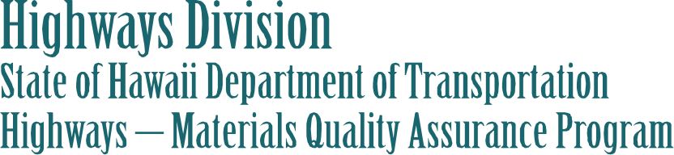

The Materials Quality Assurance (QA) Program represents the Hawaii Department of Transportation, Highways Division’s recognition of its responsibility and commitment to ensure that materials incorporated into highway construction projects conform substantially to requirements of the plans and specifications. This program provides uniform, statewide procedures to ensure personnel can perform materials sampling and testing in accordance with test methods used in the program.
All personnel performing field sampling and testing of materials for all State Highway construction projects (Federal & State funded) and all County Federal-Aid projects on the National Highway System (NHS), shall be qualified per the QA Program’s Personnel Qualification Program of the Quality Assurance Manual for Materials. In accordance with Title 23 CFR, Part 637, the sampling and testing has to be performed by qualified sampling and testing personnel.
Personnel must successfully pass a two-part (written and performance) examination to become qualified to perform field sampling and testing of materials for all State Highways construction projects and all County Federal-Aid projects on the NHS.
Personnel who successfully pass the one-part or two-part examination for the unit (e.g. Asphalt, Soils & Aggregate, and Concrete) will receive a 5-year qualification certificate for that unit. All qualified personnel must requalify every 5-years. To requalify for another 5-years, personnel must successfully pass the one-part or two-part examination for the unit they are applying for recertification.
Personnel who are certified and are actively performing field sampling and testing of materials on various State Highways construction projects and all County Federal-Aid projects on the NHS, shall participate in the MTRB’s Independent Assurance (IA) Program on an annual basis.
The purpose of the IA program is to provide uniform, statewide procedures to ensure personnel qualified under the Personnel Qualification Program remain capable of performing sampling and testing correctly, and to ensure testing equipment is checked and calibrated.
Personnel from the MTRB will schedule the annual IA evaluation with the Quality Assurance (QA) Officer at the four Highways District Offices (Oahu, Hawaii, Maui & Kauai). If you have any questions concerning the program, please contact Ms. Carla Belaski at (808) 832-3405 ext. 113 or email carla.l.belaski@hawaii.gov

Materials Testing and Research Branch
Hawaii DOT – Highways Division
2530 Likelike Highway
Honolulu, Hawaii 96819 – 2928

8 Rev.: December 23, 2019

Rev. May 5, 2015

