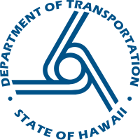

Hawai'i Department of Transportation
Voluntary Title VI Public Involvement Data Card

As a recipient of federal funds, the Hawai'i Department of Transportation (HDOT) is required to gather statistical data on participants and beneficiaries of HDOT programs and activities. Accordingly, this Voluntary Title VI Public Involvement Data Card collects information on race, color, national origin, and sex of the attendees of this public meeting. The requested information is to help HDOT improve its services to the community and ensure that all segments of the population are served equitably. COMPLETING THIS FORM IS STRICTLY VOLUNTARY. You are not required to disclose the information requested in order to participate in this meeting.

The completed forms will be kept confidential. For further information regarding this process, please contact the HDOT Office of Civil Rights at:

Hawai'i Department of Transportation Office of Civil Rights
200 Rodgers Boulevard
Honolulu, Hawaii 96819
(808) 831-7912
Email: hdot-titlevi@hawaii.gov

Ethnicity (mark one or more):

□ American Indian or Alaska Native
□ Asian (circle one or more)
Chinese, Filipino, Japanese, Korean, Vietnamese
□ Black or African American
□ Hispanic or Latino
□ Native Hawaiian or Other Pacific Islander (circle one or more)
Native Hawaiian, Samoan, Tongan, Chamorro
□ White
□ Other ______________________
Sex:
□ Female
□ Male

